Instructions for laboratory works
- Genetic symbols. Sample of genetic problems. Mendelian ratios and their modifications.
Genetic symbols
A – dominant
a – recessive
AA – dominant homozygote
aa – recessive homozygote
Aa – heterozygote
wt – wild type allele
m – mutant allele
P – parents
G – gametes
F – offspring (filii)
♀ - female
♂ - male
x - crossing
□ – male (in a pedigree)
○ – female (in a pegidree)
Sample of a genetic problem
Given:  A – yellow  a – green  ♀ - AA  ♂ - aa | Solution:  P AA x aa  G A, a  F1 Aa  Answer: F1 is yellow in phenotype and heterozygotic in genotype
Find
F1 - ?

Mendelian rations and their modifications
- Law of Dominance
P: AA x aa
G: A, a
F₁: Aa
Ratio: 100% of Aa

P: Aa x aa
G: A, a, a
F₁: Aa, aa, Aa, aa
Ratio: 50% of Aa, 50% of aa.

- Law of Segregation
P: Aa x Aa
G: A, a, A, a
F₁: AA, Aa, aA, aa
Ratio: 1: 2: 1 in genotype
3: 1 in phenotype

- Law of Independent Assortment
P: AABB x aabb
G: AB, ab
F₁: AaBb
Ratio: 100% of AaBb

P: AaBb x AaBb
G: AB, Ab, aB, ab
F₁:
Pennetta square
Gametes | AB | Ab | aB | ab
AB | AABB | AABb | AaBB | AaBb
Ab | AABb | AAbb | AaBb | Aabb
aB | AaBB | AaBb | aaBB | aaBb
ab | AaBb | Aabb | aaBb | aabb

A_B_ - 9
A_bb – 3
aaB_ - 3
aabb – 1

Ratio: 9:3:3:1

- Drosophila melanogaster as a genetic model organism to study inheritance and variability.
Morphologically males have round shape abdomen with dark spit on the latest segments. Female s abdomen is oval and pale. Males are smaller in size than females.
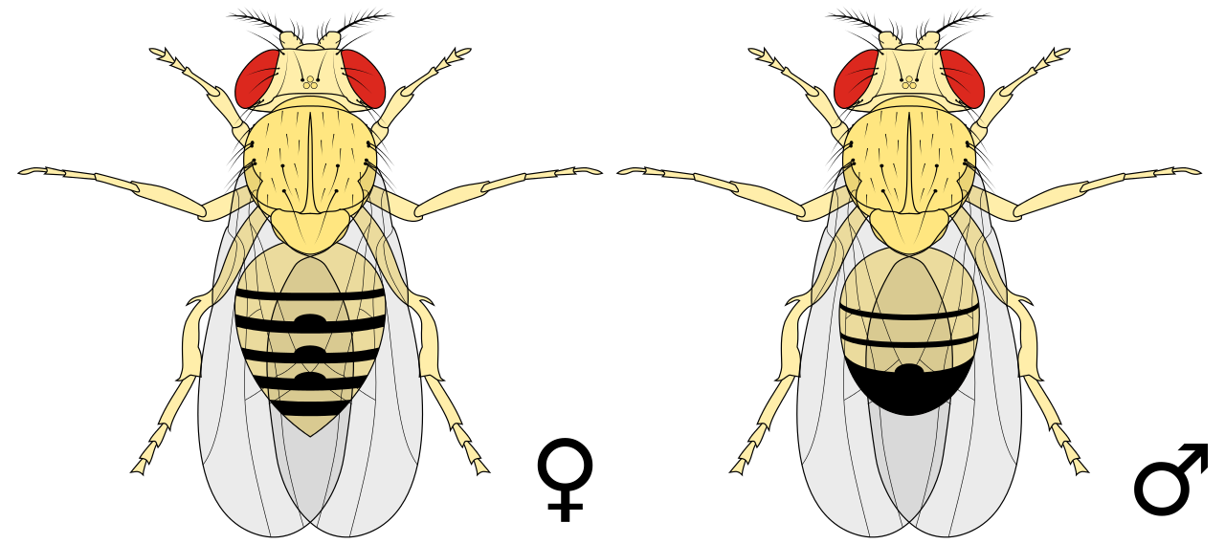

To manipulate with fruit flies ether is essential. It must be taken into account, that they are super sensitive to all types of bacterial and fungal diseases and contamination. Students have to be careful and move them only by a bird feather to avoid any physical traumas.

- F₁ crossing.
The aim of this crossing is to obtain hybrids, consequently, males and females must belong to different lines.
Example:
N x e
N x w
N x cut
The first tube -
Female is normal, male is ebony
Female is normal, male is white
Female is normal, male is cut.
The second tube –
Female is ebony, male is normal
Female is white, male is normal
Female is cut, male is normal.
- Non-allelic problems. Samples.
- Epistasis.
Pigs are white, black and red. White pigs carry at least 1 dominant gene J. Black pigs have one dominant gene E and one recessive variant of j. Red piglets are deprived of a dominant allele of inhibitor of J and E, which results in black pigment. Two white diheterozygotic pigs were crossed. F1 offspring - ?
Solution:
P: EeJj x EeJj
G: EJ, Ej, eJ, ej
Gametes | EJ | Ej | eJ | ej
EJ | EEJJ | EEJj | EeJJ | EeJj
Ej | EEJj | EEjj | EjJj | Eejj
eJ | EeJJ | EeJj | eeJJ | eeJj
ej | EeJj | Eejj | eeJj | eejj

Red piglets genotype is known. As they have not got any dominant alleles, it is eejj. Black piglets are E_jj, this the number of the black is 3. The number of white piglets is 12.

- F₁ hybrids analysis. Chi-square methods
All offspring must be separated into males and females and counted, then divided according to their traits and counted. The data must be added to the table.
 | Normal | Mutant | Total
Females | 47 | 16 | 63
Males | 51 | 19 | 70
Total | 98 | 35 | 133
This is obtained results. Now it is necessary to calculate expected or theoretical results. The following formula is used:
Total females x total normal/total
Or
63 x 98 / 133
Then, when expected figures are known, Chi-square method must be used:
χ = ℇ(O-E)²/E.

